Austin Smothers

Professor Bustamante

CSC 137

Assignment 4

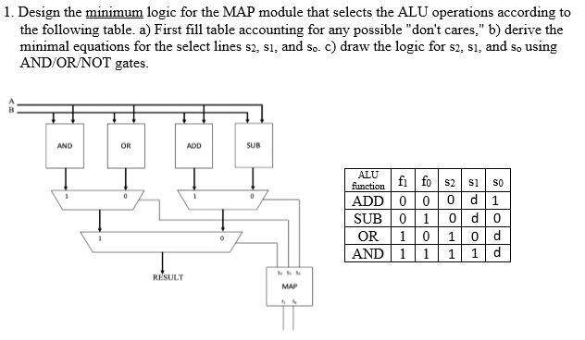

1. s2 s1 s0

|  |  |  |  |  |  |  |  |  |  |  |  |  |  |
| --- | --- | --- | --- | --- | --- | --- | --- | --- | --- | --- | --- | --- | --- |
| f1 | f0 | 0 | 1 |  | f1 | f0 | 0 | 1 |  | f1 | f0 | 0 | 1 |
| 0 | | 0 | 0 |  | 0 | | d | d |  | 0 | | 1 | 0 |
| 1 | | 1 | 1 |  | 1 | | 0 | 1 |  | 1 | | d | d |

s2 = f1 s1 = f0 s0 =

1.   

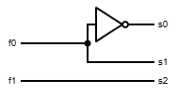

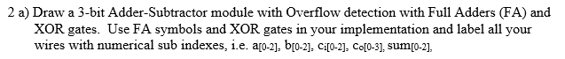

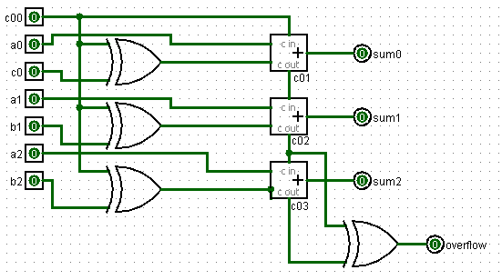

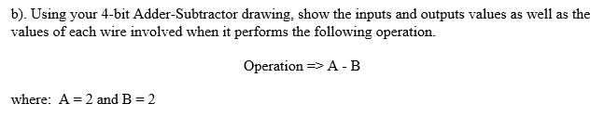



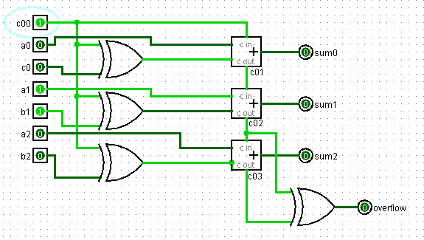

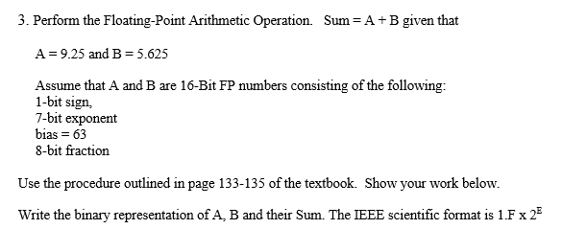

|  |  |  |  |  |  |  |  |  |  |
| --- | --- | --- | --- | --- | --- | --- | --- | --- | --- |
| 16 | 8 | 4 | 2 | 1 | .5 | .25 | .125 | .0625 | .03125 |
| 0 | 1 | 0 | 0 | 1 | 0 | 1 | 0 | 0 | 0 |
| 0 | 0 | 1 | 1 | 0 | 1 | 0 | 1 | 0 | 0 |
| + | = | | | | | | | | |
| 0 | 1 | 1 | 1 | 1 | 1 | 1 | 1 | 0 | 0 |

= 15.875

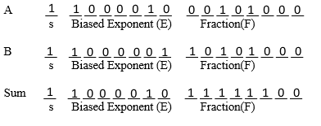

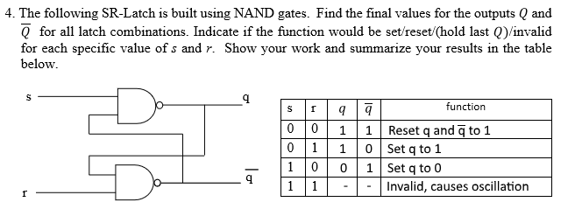

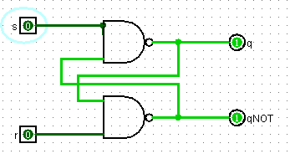 s=0, r=0 sets q and $\overline{q}$ to 1

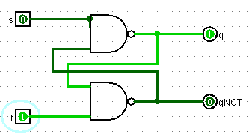 s=0, r=1 sets q = 1 and $\overline{q}$ = 0

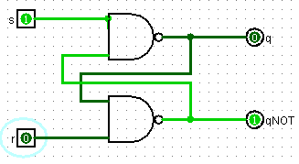 s=1, r=0 sets q = 0 and $\overline{q}$ = 1

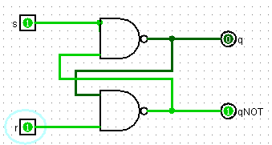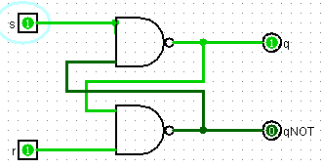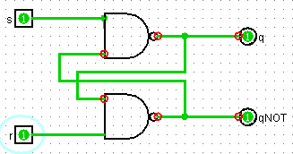

s=1, r=1 will store the last value of q if q != $\overline{q}$, but causes oscillation if q = $\overline{q}$.

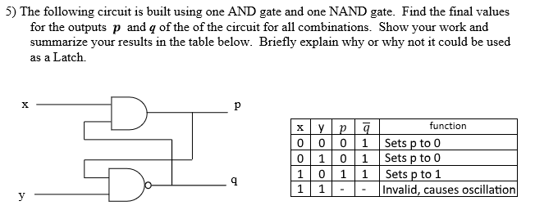

This cannot be used as a latch, as it functions as a wire for p=x and q=1, but adds an oscillation case. It also will not store the value of p when turned off, so it has no "memory" so to speak.

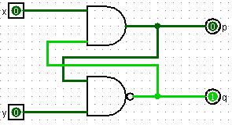x=0, y=0 sets p=0 and q=1

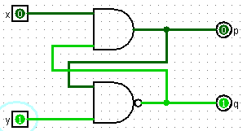 x=0, y=1 sets p=0 and q=1

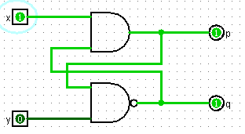 x=1, y=0 sets p=1 and q=1

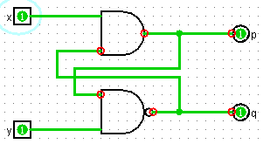 x=1, y=1 causes oscillation

